Creating a Shot List

Learn to create a shotlist for your shoot

Creating a Shot List
A key part of planning the coverage for a scene is to create a shot list – or a list of camera set-ups and angles for each scene - by planning the actors’ blocking and the camera positions on paper. Rarely at this stage does the producer have any locations locked, so although it’s impossible to block specific moves, you can still determine where and when you want a long shot, a master shot, close-ups, and medium shots. The goal is to arrive at the number of setups, or times the camera has to move to a different position, for each scene. This will help determine the rough shooting schedule and number of days needed to shoot the movie.
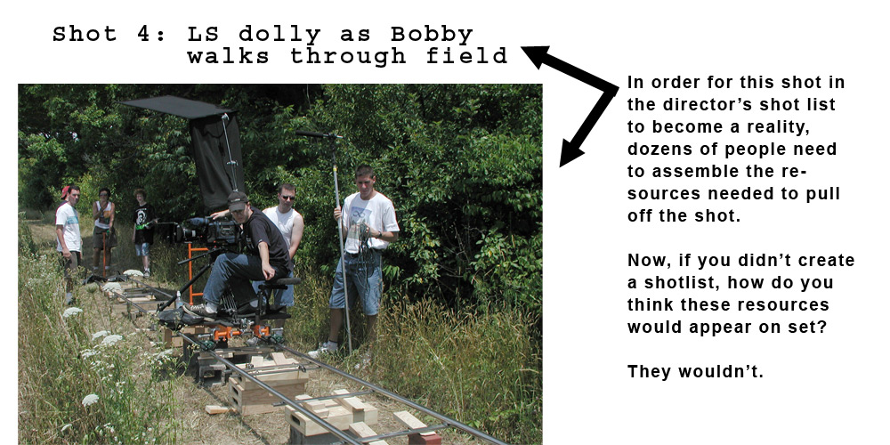

I like to draw vertical lines through the scene with a pencil and ruler to identify how much of the scene will be covered by each camera setup. I then write the setup name in the margin next to each line.

The result will be a shot list of the scene that lists each camera setup. For example:
- Shot 1: Master shot of entire scene
- Shot 2: MS OTS (medium shot, over the shoulder), Bill at table, x2 (this means you're going to get two frame sizes from the same camera position - usually a medium over-the-shoulder shot and a clean, tighter close-up)
- Shot 3: MS OTS, reverse, Kitty at table, x2
- Shot 4: Insert of the woman’s wine glass
- Shot 5: Dolly into waiter

Once the shot list is done, sit down with the director of photography and first assistant director to build a rough shooting schedule to determine whether the budget will allow for all the proposed setups in your shot list. Be prepared to consolidate or reduce the number of setups or cut any complicated dolly, crane, or jib moves during this process.

During the location scouting process, use the shot list to determine the actors’ final blocking, camera position, lighting options, and technical requirements before committing to the location. Once a location is secure, plan the final blocking and make any necessary adjustments to the shot list, so when you go into rehearsals with the actors, you already know how they will move and what the frame will be.

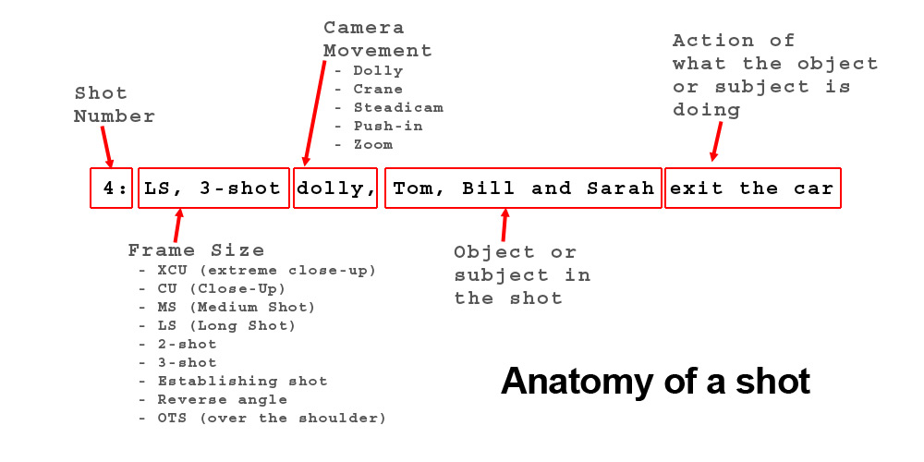

Keep these factors in mind when planning the coverage of each scene:
- Frame size – Typically, shots of varying frame sizes will cut together much smoother than intercutting shots of the same frame size. For example, cutting from a medium shot of a man pulling a wash rag out of bucket of soapy water to a medium shot of him throwing the rag onto the hood of his car to wash it, may feel jumpy. Try shooting a close-up of the bucket of water, then cutting to a medium shot of the car, then to a close-up of the man’s determined face, then to a long shot of the man washing the car in the driveway. One notable exception to this guide is when shooting a dialogue scene between two people, where it is perfectly acceptable to intercut between similarly-composed shots.
- Camera movement – Plan for any dolly, jib or steadicam moves, pans, tilts or zooms and make sure the movement will flow into the next shot. For example, if the camera dollies from behind a plant to reveal a long shot of a woman reading a book on the couch, the next shot may be aided by a slow dolly push-in to a close-up of her face. The kinetic movement of the camera is continued from one shot to the next through the dolly move.
- Pacing – What is the pace of the edit? Whether the scene is a rapidly-paced montage or a slow, meandering scene, determine how the coverage will be edited in post-production.
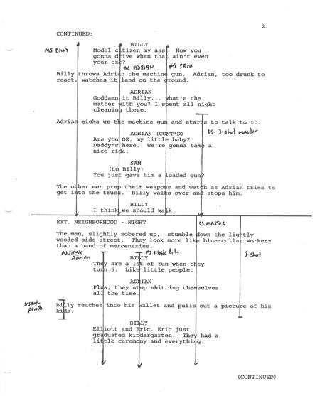
For example, I recently shot a commercial for a new sports plane (see the commercial at www.jasontomaric.com/icon.mov). Conceptually, I wanted the audience to think the commercial was really for a high-end sports car, before revealing that the car is actually a plane. I wanted the piece to be a very quickly cut sequence of the driver stepping into the car, turning the key, pulling back the throttle, smash cutting to his face, long shot of his point of view cruising down the runway, and so on. Each of these shots ended up lasting only half a second, which required us to pre-plan each shot to ensure it would cut smoothly into the next shot. The result was a testosterone-infused commercial the uses the editing style to invoke a feeling of power, fun and elegance.

- Necessity – Every minute spent on set costs money. From the cost of cast and crew to equipment rentals and location fees, it can be an expensive proposition to shoot footage without knowing how it will cut together. It’s worse to discover discontinuity or coverage problems in the editing room, which may require additional shooting, so proactively look at each shot, consider the music and sound effects and determine if each shot is truly necessary to the telling of the story.

A great way of ensuring you have enough coverage is to draw vertical lines across the parts of each scene you anticipate covering in each shot. Similar to the way a script supervisor marks a script on set, do the same with your coverage. This will help you see if there are any gaps in coverage in the scene.

