Directing Actors on Set

Learn how to work with actors on set, what to say just before you call "action," and after you call "cut."

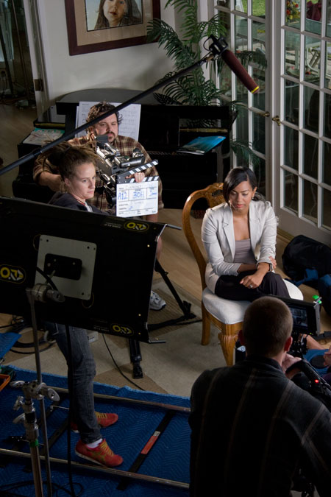

Since movies are shot out of order, it's important to help the actors understand how the moment they're playing works into the overall storyline. So three simple directions, all of which you've already discussed in rehearsal, are sometimes all you need to help the actors get into the right mindspace.

Before You Roll
After you run through the entire scene, the crew will burst into action setting the camera, rigging lights, dressing the set, and preparing to shoot. During this time, work with the actors to help them achieve the right mind set for the moment they are about to perform.

There are three main points to review with each actor before they are ready to shoot.

- Before and After - Walk the actor through what their character is doing, feeling and thinking in the moments that lead up to the scene you’re shooting. It can also be helpful to rehearse these moments to help the actor get in the proper frame of mind. Describe what the character is doing in the moments after the scene is finished. This will give the actor a context for the scene and help him lead into the performance.
- Motivation - Every character has a purpose, or objective they wish to fulfil in every scene. Although you and the actor have worked this out in the rehearsal stage, its important to reiterate what the character wants in this scene. This objective is the guiding through-line for the scene. Let’s say the scene is about a mother asking her little boy how his school day was. Although he’s telling her about his math test, he’s secretly trying to sneak cookies from the cookie jar behind her back. This objective makes the scene not about math tests, but about the little boy talking about math tests to keep his mother from seeing him steal cookies.
- Subtext - How does the character really feel beneath the lines? Although he may be saying one thing, what is he really thinking and feeling? Directing the subtext is the most powerful way to achieve a realistic performance.
If you and the actors have done your homework during the rehearsal process, this should be all you need to say. The actors will then go to their trailer or their room and mentally prepare for the scene.

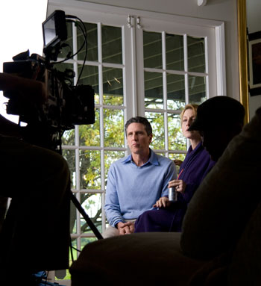

Acting can be a very lonely experience, especially when actors are left without any support from the director. The pressure is tremendous; between the lights, the camera and the crew staring at them during every take. A good director will always go right to the actors after calling cut to provide immediate feedback and support.
After you Call “Cut”
Once the scene is finished and you call cut, your primary responsibility is to go directly to the actor to give him feedback while the 1st assistant director confers with the director of photography and the production sound mixer to determine the technical quality of the take. If the performance was what you were looking for, simply say, “Good Job. Let’s try it again.” If you’d like to go see a different performance, always be positive and SUGGEST a different approach. Actors can be sensitive and sometimes vulnerable when they open up in front of the camera and rely on positive support from the director.

Be simple and clear in your direction, “That was great, but let’s try it a little smaller,” or “Give it a little more energy,” or “I like how fidgety you were in the last take, but this time, make your movements a little more subdued.” Generally, this is the extent to which you will need to adjust the performance.

- Always be positive and supportive. The secret to suggesting change is to “try” a different approach. Never tell the actor she played the scene wrong, or made a mistake. Understand that playing a moment is subjective and isn’t necessarily right or wrong.
- Once you decide to shoot another take, quickly reset and roll again, while the actor is still in the proper frame of mind. The more time passes between takes, the more difficult it will be for the actor to get back into the proper mind set. Some directors like to roll multiple takes without stopping the camera.

Balancing Performance with Sound and Picture
When the audience watches a movie, they experience a complete soundtrack, sound effects, visual effects, color correction, and editing style, all of which support the actors’ performances. Unfortunately, actors and crew members on set do not have the luxury of seeing or hearing all these elements when the scene is being filmed. It is therefore your responsibility to paint as complete a picture of what the audience will see and hear so the actors can give a performance that works in conjunction with all the other creative aspects of the movie.
You, the director, are the only person who can see the final movie in your head and it is your responsibility to describe this vision to the actors so they know how their performance will be complimented with the music, sound effects and special effects.
For example, in the opening title sequence of Time and Again, I asked actor Brian Barron to balance the crushing exhaustion of the prison break with the overwhelming sense of freedom of having had recently escaped. His objective was to play the scene with two motivating factors: fatigue and his basking in his new-found freedom. Cinematically, I chose to shoot the scene with wide, sweeping vistas and used warm, soft lighting to convey to the audience that this field is safe – Bobby Jones is safe, and free.

The audience, however, got a very different feeling from the scene, once I added the sound design and music. Although the look of the scene was warm and comforting, I chose a music score that added a foreboding overtone by using discordant, cold instrumentation. I was able to instill an emotional response in the audience using techniques other than the acting. The final result is a scene that, whereas Bobby is tired and content in the field, the audience senses something wrong, and that unbeknownst to Bobby Jones, something is about to happen.
Sound effects, cinematography, music, and visual effects can all create these overtones, with each aspect adding to the drama of the scene. Acting is only one part of this “dramatic pie,” and by walking onto set with a firm understand of how all these elements work together and explaining this balance to the cast and crew, you can fine tune the performances to the proper level and intensity.

