How to Shoot a Scene

Learn the five stages of how to shoot a scene: block, light, rehearse, tweak and shoot.

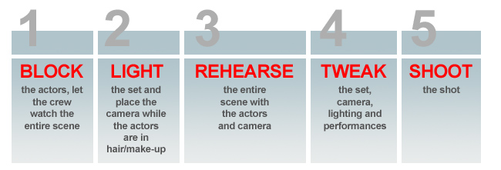
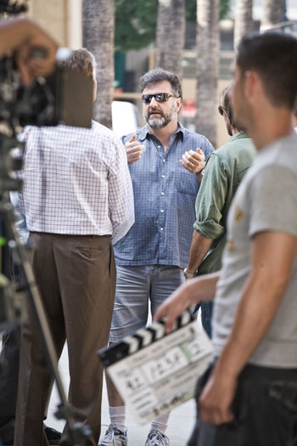

On the set of "Fred and Vinnie," director Steve Skrovan discusses the scene before the cast and crew begin any work. This is critical to ensure everyone understands the nature of the scene and the director's goal. Think of this meeting as being the 30,000 ft overview.
Given that the proper preparations have been done – shots were planned, actors were rehearsed, the department heads had a chance to visit each location to determine the shots and lighting, locations were dressed, parking and transportation had been set-up and the cast and crew are on their way, the process of shooting the movie begins.
Once the crew arrives on set, the grip and lighting trucks have been parked and the location manager has made contact with the location owner, the crew will generally make a beeline for the craft services table to grab a cup of coffee and a bagel. Professional crew members arrive early to set, well before their call time so they can eat and be ready to begin work exactly at call time.

Begin the production day by going over the plan and logistics for that day of shooting – what scenes will be covered, where on the location shooting will take place and how the location can be used. The first assistant director should point out the restrooms, what parts of the set are off limits, where craft services, hair and make-up, and equipment storage is located, where the designated parking is, and all other location-specific details.

Then, it’s your turn to walk the crew through the scenes you are going to shoot. Explain what the scenes are and how they relate to the overall story, where they will be filmed, and how they fit into the production schedule. If the entire crew understands the shooting schedule, they will be much more invested in the day of shooting, feeling a part of the creative process rather than grunts moving and setting up equipment.

Once the briefing is done, you can begin work on the first scene of the day. Generally, whenever shooting a new scene, the process can be broken down into five stages: block, light, rehearse, tweak and shoot.
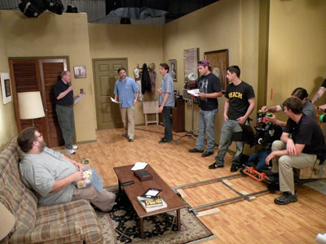

Steve blocks the actors for a simple scene. It's not uncommon for this blocking to occur in private so the director, actors and director of photography don't feel undue pressure from the crew.
Step 1: Block
Once the production team begins a new scene, the very first step is for the 1st Assistant Director to bring all essential cast and crew members to the set so you can walk through the entire scene. During this walkthrough, block the actors, or determine their position and movement within the set. Usually, you should have spent significant time on set before the shoot to determine the blocking, although sometimes if a location is not available, you may figure to out the blocking the day of the shoot. Ideally, storyboards have been created which illustrate the actors’ movements.

Many novice directors, especially when under a time crunch, may elect to forgo the blocking and rehearsing phase, choosing instead to immediately shoot the scene. Choosing to shoot without the proper rehearsals means the actors may not know where their marks are, the 1st assistant cameraman will not have an opportunity to set focus marks, the dolly grip will know neither the stopping and starting points of the camera nor the speed of the dolly, the boom operator will not know where the frame line is increasing the risk of the microphone dipping into the frame. When the cast and crew is not clear on what is happening in each shot, you will have no choice but to shoot take after take, adjusting each time. This approach ultimately ends up costing more time than if you had simply blocked and rehearsed for everyone before rolling the camera.

The blocking process includes:
- Determining the starting and stopping points for each actor. The 2nd Assistant Cameraperson will use paper tape to set marks on the floor to designate the exact positions for the actors, enabling the camera crew to set focus marks, the gaffer to focus the lights on the right spots, the DP to choose the correct lens and the Production Designer to dress the appropriate parts of the set.
- Determine the camera coverage. During the blocking process, the DP will work with you to determine the placement of the camera and frame size. Usually this is worked out in advance – for example, a simple dialogue scene may consist of a master shot, close-up coverage of each actor, and any necessary inserts. Scenes with more elaborate blocking may require more intricate camera moves, so work through each camera position with the DP to ensure proper coverage of the scene.
- Determine the lighting. During the blocking process, the DP is discussing the lighting requirements with the gaffer and key grip – figuring out where to place the key light, accent lights, hair lights and broadly designing the cinematic look of the scene.
- Dressing the set. Once the production designer understands the blocking, she will begin determining which parts of the set need to be dressed for each camera angle.

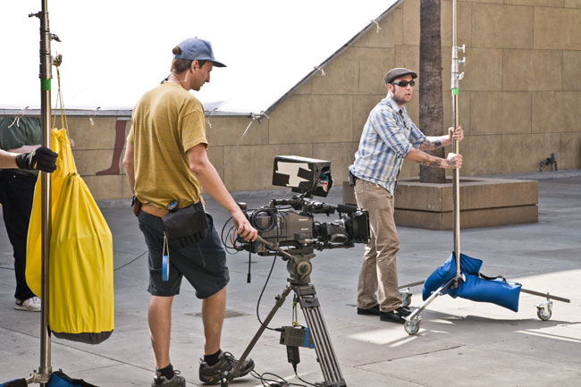

While the actors are in hair/make-up and costume, the grip and electric crews begin lighting the scene.
Step 2: Light
Once the scene is blocked, the actors are taken to the wardrobe supervisor, hair stylists and make-up artists. The 1st assistant director gives the DP control of the set where the electricians and grips begin hanging lights, setting up reflectors, laying dolly track, running power to the lighting fixtures, and lighting the scene as completely as possible. Concurrently, the 1st assistant cameraman will be setting up the camera, moving the monitors at video village and prepping the appropriate lens per the DP’s orders.
- It’s important for the DP to communicate clearly with the 1st assistant director when giving time estimates for lighting a scene. Most often, the day’s production schedule has already been developed accounting for the time needed to light each scene. Although pre-planning is important, factors such as weather, unknown locations, changes in blocking and scheduling issues sometimes force the DP to change his lighting plan. Therefore, it is extremely important to give the 1st AD accurate estimates so the 1st AD can coordinate with all the other departments.
- Standins – Ideally, while the DP is lighting the scene, the crew will need to see the actors in position so they can focus and tweak the camera angles and lighting. Because the actors are in hair and make-up, studying their lines and preparing for their upcoming shots, stand-ins (people who bear a similar height, skin tone, hair color and look to the main actors) are used so the DP can continue working. Low budget movies may require the actor to return to the set and stand in position. This can be both fatiguing and frustrating, as it prohibits him from doing his work. Try to avoid using your actors on set to stand in whenever possible.
- Rehearse moves – During this process, the DP will have the stand-ins walk through the blocking so the dolly grip and camera operators can rehearse the shot, working out any problems that may arise.

Step 3: Rehearse
Once the set is lit, the camera is in position and the actors are ready, they are brought back on set to rehearse the intricacies of the scene. Whereas the scene was roughed in during blocking, the rehearsal phase gives the director and actors a last-minute opportunity to work through emotional details of the scene. Usually most of this emotional work has happened weeks before the shoot, but given this is the first time the actors have seen the location, they need a little time to adapt their performances to the real space of the set.
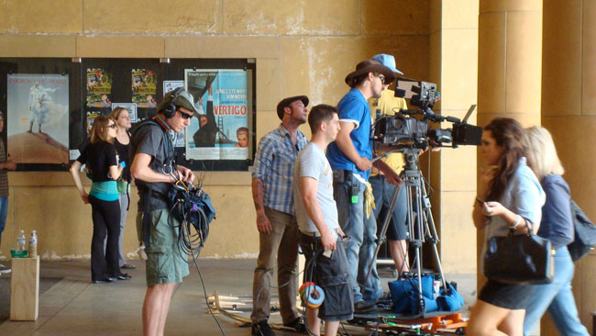

Always rehearse the scene with the camera crew to ensure the focus, dolly moves, lighting, boom position and set dressing are correct.

Step 4: Tweak
During the technical rehearsal of the scene, the director may make last minute adjustments to the actors' performances, the DP is carefully watching the scene to ensure the lighting is correct, the camera operator minds the frame, making small adjustments to the elements in the frame to ensure ideal composition. The tweak stage is the final opportunity to fine tune every aspect of the frame before rolling a take.

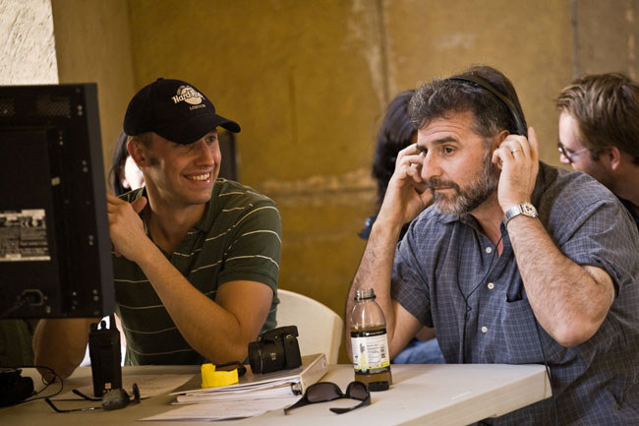

During the scene, the director and director of photography are always at video village watching the take. The director is watching for the actors' performance while the DP is watching the frame.
Step 5: Shoot
Now that the scene has been rehearsed, lit and the cast and crew are all clear on what is happening in the shot, it is time to roll the camera. The first assistant director will call for quiet on the set and will give the command to roll camera, roll sound, and mark the shot. After the second assistant cameraman marks the shot with the clapboard, you are free to call action.
- Be sure to let the camera run for a few moments before calling action and after calling cut—this extra footage will provide pad for the editor to work with when cutting the film.
- During the take, watch the performances carefully on the monitor and look for authenticity, realism, and emotion from the actors. Be aware of how the actors move around the frame and how well all the technical elements play together. Does the moment feel real? Are the actors over- or underacting? Does the blocking seem real and motivated? Is the scene full of subtext, character, and driving story elements? Watch carefully and make mental notes of what to change or adjust for the next take.

