Storyboards

Learn to use storyboards and pre-vis techniques to share your vision with the cast and crew

Once you’ve developed a shot list for each scene, the next step is to sketch each setup and indicate specific framing, camera moves, and actor movements. These sketches are called storyboards.

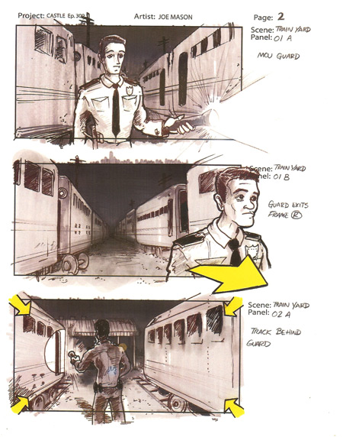Use storyboards to previsualize the action that occurs within each frame to convey your vision to the cast and crew. By thinking about the shots in advance, the crew is better able to prepare and plan the shooting schedule, art direction, lighting and camera needs and most importantly, you’re better able to judge the pacing, movement, and structure of the story before getting to the set.

Remember that revising shots on paper is a lot cheaper than revising shots on set or in the editing bay. The alternative to previsualizing the movie with storyboards is arriving on set with no one on the cast or crew knowing what the you want or how a scene is to be framed, lit, or dressed. Time will be wasted and you may not get the desired coverage as you’ll be too worried about how to cover the scene with the camera rather than focusing on perfecting the performances.

Do not however, be so heavily reliant on the storyboards that you can’t deviate from them if elements out of your control affect the shoot. Oftentimes, productions run over schedule due to technical problems, scheduling oversights, or weather-related issues, forcing you to cut shots and even entire sequences at the last minute. Flexibility in adapting the storyboarded shots makes it easier to adjust to the continuously changing demands of the shoot.

Although storyboards are used to help work out shot angles and camera positions, you can also use them to determine how the shots will be edited together. One outstanding technique is to cut the storyboards together in the editing room and record the scripted dialogue to create a storyboard movie, even adding music and sound effects. Watching the edit from one storyboard to the next will give you a sense of pacing and shot flow. Virtually all major movie studios use these techniques to work out the pacing and flow of shots well before going into production, saving both time and money.

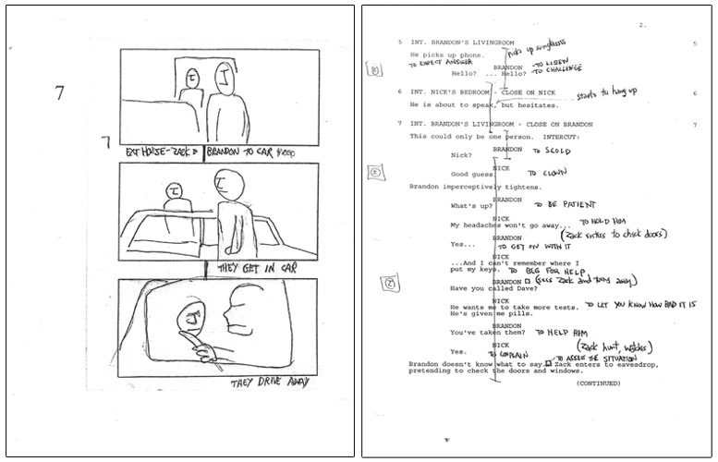

Grease director, Randal Kleiser, draws his storyboards on the blank page facing the script page. Although the drawings are simple, they convey the requirements of a good storyboard: a sense of frame size, the direction the actors are facing and any necessary set pieces.

Once a tool utilized only for special effects sequences, pre-visualization software can used to create an animatic, or animation of each scene, allowing you to play with the camera coverage, editing style and frame composition before stepping foot on set. Remember, it’s better to spend the time in pre-production and guarantee usable results than shoot blindly in the field and discover problems later in the edit bay.
Once complete, storyboards should be copied and distributed among the department heads. I also find it valuable to post a spread of the storyboards on an empty wall of the production office and on set so everyone can readily access and see them.

Although many filmmakers create storyboards by hand, there are a number of 2D and 3D programs that make rendering storyboards easy. For creating 2D storyboards, check out a program called “Storyboard Artist,” and for 3D boards, “Poser” and “DAZ Studio.”
- Take your favorite movie scene and storyboard it, shot by shot. Study WHY the filmmaker made certain choices about camera placement, lighting, and timing. Reverse engineering a scene is a great way to understand coverage and the choices the filmmaker made. Even though a hot may only last a fraction of a second on screen, the director spend dozens of hours planning, shooting and editing that moment for a very specific reason.

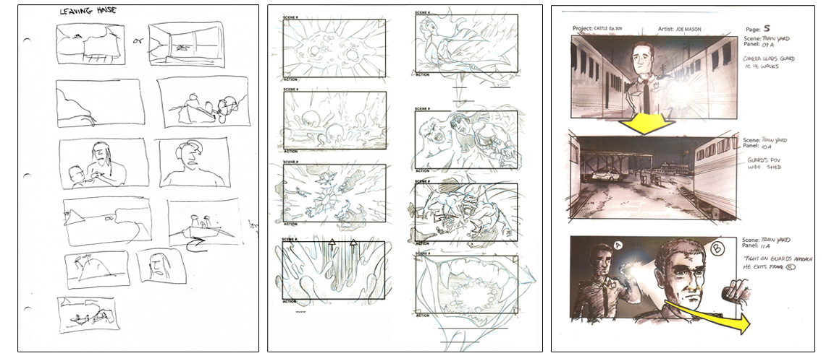

Storyboards can range from very simple sketches such as the storyboards from "Blue Lagoon" (left), to detailed, shaded drawings like these storyboards from the show, "Castle" (right)

Storyboard Tips
- Draw framelines and characters accurately to properly convey actor blocking and camera positions.
- Establish the shot size and framing of subjects is within the frame. The reader should be able to determine if the shot is a long shot, medium shot, or close-up.
- Include important set, set-dressing, prop, and wardrobe information in each frame.
- Convey movement of subjects and objects in the frame with single, bold arrows.
- Convey camera movement with 3D arrows.
- Label each storyboard frame with a brief description of what is happening in the shot, and even lines of dialog. A well-done storyboard should incorporate all elements of the script so that it reads like a comic book. Pictures represent the visuals, and sound and dialog are written below each frame.
- When representing different characters, draw a simple characteristic to differentiate one character from another, i.e., a hat and necktie for the lead male character and a bow and dress for the lead female character. Storyboards don’t have to be great works of art… just tools to convey the framing of the object or subject within the scene.
- Try drawing the scene first on blank paper, then draw the frame box around the action you want. Sometimes, it’s easier to storyboard this way than to draw the shot within predrawn frames.
- Spend extra time storyboarding any shots that incorporate digital effects. Consider working with the digital effects artist to develop any digital effects shots so that they are properly shot and framed for their post needs.

