The Visual Story

Learn the visual elements of shape, space, line, color, rhythm, movement and tone to frame the story.

It's easy to think about look and style of a movie in terms of the editing style, the camera movement, and colors in the frame. But these are all part of a bigger component of the visual story that uses composition of elements within a frame, specific movement of the camera or objects, colors and the use of space to subconsciously convey the story to the audience. These tools evoke a feeling that frames the performances, and while never overshadowing performance, the elements of the visual story can have almost as big of an impact.

The visual story can be broken down into seven elements: space, line, shape, color, tone, movement and rhythm. Now this may seem like a pretty academic exercise without much practical application, but if you think about movies that have had an impact on you, each one demonstrates a careful attention to each of these components.
Before we get into the details of creating a visual story, it's important to keep in mind that the visual and aesthetic elements of the story must always support the story and the characters.
Space
The medium of film or digital is inherently a flat medium. The movie or television screen has height and width, but no depth. Part of your job as a director is to create depth within the frame by using a number of tools including:

- The composition of elements in the frame to imply dimension
- The use of the lens to either expand or compress the space in a frame
- Moving the camera to create a greater sense of depth or compression

There is a principle in art called the vanishing point, where if you were to reduce an object to simple lines, the vanishing point is the point at which those lines converge. Composing an object so the vanishing point appears on screen, creates a greater perceived depth in the frame.
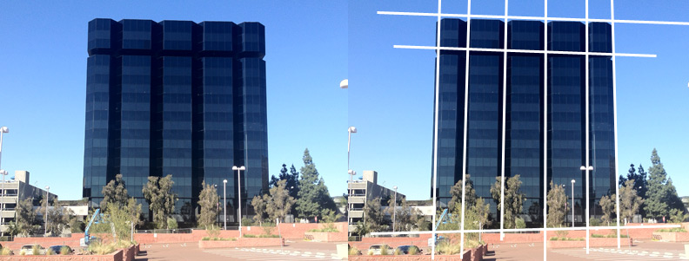

In this first example, we shoot the building flat, so it only appears in two dimensions – height and width. This composition, combined with no foreground or background elements, creates a flat frame, devoid of depth.

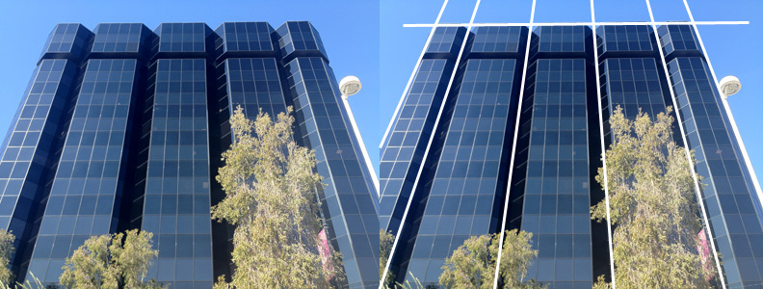

In this second example, we add a little depth to the frame by creating a vanishing point. The frame is still very flat because the vanishing point occurs off frame.

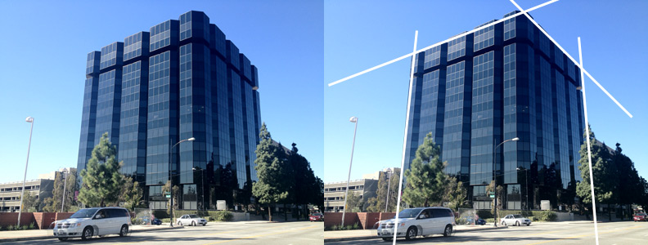

In this third example, we frame the building in a way to show its height, width and length. While this adds depth to the building by revealing all three dimensions, the frame still appears flat because the vanishing point is so far off frame.

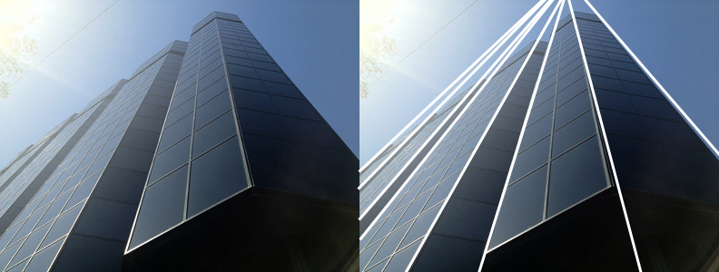

Finally, this fourth shot has tremendous depth. Even though we are only showing height and width, because the vanishing point is so close to the frame edge, it creates a substantial amount of depth to the frame.
As with all these compositional guides, the depth of the shot should be rooted in the story, so after you determine how much depth you would like to portray in a shot, you can subsequently choose how to frame objects to create more or less depth. For example, if the story beat demands the character to feel overwhelmed by the space he's standing in, you'll want to frame the surrounding buildings in a way that creates more depth – the size of the environment is stifling to the character. Conversely, shooting a character flat against a wall can convey a flat, emotionless world.

You can control the depth of the space in the frame largely with your lens choice. Knowing that a long lens compresses elements in the image, you may choose to shoot the majority of the movie with a long lens. Conversely, to create a sense of spaciousness, use a short-focal length lens. Additionally, shooting through foreground elements can help create either an exaggerated sense of either depth or compression, depending on your lens choice.
Now in addition to the lens choice, your camera placement within the space in which you're shooting can have an impact on the visual style of your movie.
Line
The elements within a frame can be divided into lines, whether those objects are people, parts of the set, or even movement, these lines help convey an emotional sense to the audience. The lines of a shot can be:'

- Horizontal or Vertical lines - Although these lines convey a sense of balance, an overwhelming composition of either horizontals or verticals can make a very strong visual statement.
- Diagonal Lines - Diagonals create a sense of power - whether the vertical is going uphill or downhill in the frame, can imply an escalating or deescalating power.
- Random Lines - Random lines can convey confusion and chaos.

Shape
Similar to line, the shape of compositional elements in the frame refers to the area objects take up in the shot, and the shape of that area. Choosing the size and shape of objects impacts the audience's sense of balance in the shot and can draw their attention - and bias - towards or away from a compositional element.
Color
One of the most important aspects of visual storytelling is the use of color - or the lack of color - in a shot. Whereas most filmmakers will choose a color palette for the overall movie, the use of color can be further distilled into each scene, in which color is used to represent a movement of feeling. One example is in Ridley Scott's Black Hawk Down, the warm and cold colors are used in a contrary fashion when compared to their more typical use. Scenes in which the soldiers are embroiled in combat, or when the stakes are high, are shot in warm, unsettling colors - oranges, yellow and burnt reds. Contrary to convention, scenes in which the soldiers retreat to the safety of their camp are shot with heavy blue tones. Even the commander in a safe control center are shot with warm tones during combat situations to show the chaos and tension experienced by the men in the fields are also shared by the commanders.

You can read a more detailed color study of Black Hawk Down here.

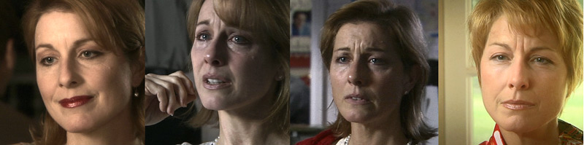

These images are taken from the short film, Currency. Note the emotional state of the main character and how the color and tone of the lighting accentuate those emotions.

Tone
The tone isn't the emotional context or pacing, but rather the ratio of tonal values in the frame. Do you want people to be evenly lit to create a low contrast ratio? Or do you want a more extreme contrast ratio between the bright and dark sides of the actors' faces? Do you want parts of the set to fall into blackness or into bright white overexposure? Do you want to play with the contrast between elements, or do you what the audience to see everything? Because much of this look is created through lighting, always work with the cinematographer in pre-production to determine the tone of the cinematic story.
Remember that these guidelines are just that - guidelines. Choose which techniques best serve your story, but make sure you're serving the story - not serving the technique.

Movement
While you can certainly control the kinetic intensity of the scene through the blocking of the actors, you can exert an even greater degree of control through the movement of the camera. How fast does the camera move? Do you want the camera to be static with each shot deliberately framed? Do you want the movie to have a slow fluid movement where the camera is always slowly dollying? Your decision as to how to move the camera can either support, or be disconnected from, the blocking of the actors.
Rhythm
Rhythm is how the placement of objects within the frame create an emotional response in the audience. Repetition and movement of an object within the frame all contribute to the rhythm of the shot. To learn more, I recommend reading “The Visual Story,” by Bruce Block.

