Working with Extras

Learn how to find, cast and direct extras.

Casting Extras
Extras are nonspeaking actors who work in the background to bring life, movement, and a sense of realism to a scene. Extras are the patrons in a restaurant behind the main characters, they are the passersby on the street and the people sitting around our characters in the movie theater. Extras add production value, scope, and size to a movie. In Hollywood movies, the job of directing the extras usually falls on the 1st assistant director, but in independent movies, that job will probably fall on your shoulders.

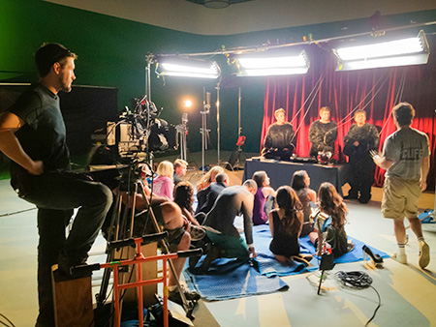Although Hollywood productions rely on the casting services of professional agencies such as Central Casting, finding extras for a low budget movie can be as easy as tapping into local resources:

- Contact local theaters, schools, and university theater programs. Many aspiring actors are willing to work for free simply to get the chance to be in a movie.
- Avoid shooting in high-production towns like Los Angeles or New York. These cities attract people who are looking to make a living as actors and it is more difficult to find people who are willing to work for free than in non-production towns.
- Always research the setting and time period of your story so you can both costume and direct the extras so they convincingly portray the environment.
- Providing food on set is a great way to help attract extras.

Casting Clone
When I shot my first feature film "Clone" in Ohio nearly a decade ago, I had less than $25,000 to create an authentic post-apocalyptic world. One of the ways we did this was by populating the scenes with over 3,000 extras, all of whom worked for free. We were able to cast so many people in part, by casting local news anchors and weathermen who would help us spread the word about an upcoming shoot. So successful was this campaign that we had to cancel one battle scene when we had almost a thousand people call to sign up. Use your local media to help generate excitement and you will find an abundance of excited people willing to work as extras in your movie.

Directing Extras
Working with extras is similar to working with the principal cast.

- Be as concise as possible as to what each extra needs to wear and bring to the set. On larger budget movies, the production provides hair, makeup, and wardrobe for the extras, although this may be cost-prohibitive on lower budget projects.
- Be sure to provide an area on set to hold the extras between takes. This area needs to be off the set and out of the way of the crew.
- Make sure you have appropriate restroom facilities to accommodate the number of extras working on set.
- When directing extras, explain to them the nature of the scene and what type of atmosphere they need to create in the background.
- Extras are rarely experienced actors, so they need extra attention and positive feedback. Be clear in your direction and quick in your praise.
- If necessary, give groups of extras specific direction, especially if their action is happening directly behind the principal actors.
- Beware of extras who try to draw attention to themselves. Move them to the back, out of sight of the camera. Good extras are invisible to the audience.
- Extras should never talk during a take even if they appear to be making noise or speaking on camera; they should always mime the action so sound editors can put the sound of the background in later.
- Always be supportive. Many extras have never had any experience shooting a movie and are probably volunteering their time. Always thank them and let them know when they do a good job.
- Make sure each extra signs a release form before stepping on set.
- Keep a mailing list of the extras so when the movie is finished, you can notify each person of how to see the film.

