Working with the Military

Learn how to approach and work with the US military for your movie.

The Military
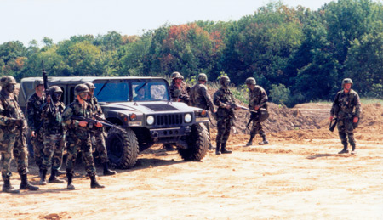

We got to work with about 20 soldiers, 2 humvees, 3 tents and a bunch of military equipment for a flashback scene from my low-budget feature film, "Clone"
There were a number of times I needed soldiers or military vehicles for my independent productions. After calculating the costs of renting wardrobe, props and vehicles from various costume rental facilities, hiring extras from casting agencies and renting equipment from Army Navy stores, I realized that I may as well procure the actual military. It would be cheaper, the soldiers would look and behave like real soldiers and they would bring all their own equipment to the set.

Although it would have been impossible to hire the US Army, Navy, Air Force or any other Federal military unit, the local National Guard is a different entity. Comprised of local civilians who train once a month, and for a two-week boot camp each year, each soldier has his own uniform and basic equipment, with local vehicles and larger gear like tents and weaponry stored at regional facilities. The National Guard is managed and operated by the state, although in times of war, they fall under the command of the Federal government.
I had the opportunity to work with the National Guard twice, once for my feature film, "Clone" and once for a documentary I shot, "The World Without US." I approached the Ohio Army National Guard and after two months of negotiations, letter-writing and meetings, secured permission to use about a dozen soldiers in full combat gear, weapons and vehicles for a scene from my movie, "Clone." The best part is that I didn’t have to pay a penny.

While the process to secure permission was a little daunting and time consuming, once I received approval from the state, it became much easier to ask each soldier to participate. As word spread about the film, more and more people became interested and we got the 20 men we needed to shoot the scene.

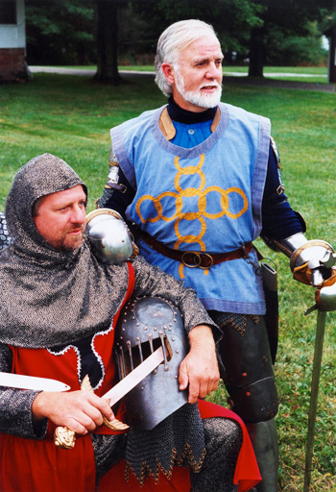

Reinactors like this mideival group are often experts in a time period, creating accurate costumes and props and most importantly, understanding the culture and behaviour of the people.
Reenactment Groups
For a complete list of reenactment groups, clickhere.
Another outstanding resource is to find reenactment groups who specialize in recreating specific time periods. Some organizations create the costumes and equipments from medieval times by handmaking chain mail, forging swords, custom sewing garments with authentic fabric and dyes, and studying the cultural behaviour of the people of the time. Others may be military reenactment groups, such as Civil War reenactors who craft uniforms accurate down to the button, old muskets, and even sporting the moustaches and period-appropriate haircuts. Regardeless of the time period or what the reenactors are depicting, they all have one thing in common - an insatiable love and obsession with creating history accurately, and this obsession is a gold mine for filmmakers.

If you're producing a period film, it takes a lot of time and effort to research and assemble the props and wardrobe, so why not let the experts do it for you? By hiring a reenactment group, you will get authentic performances, accurate costumes and a plethora of details props, all created by people who are passionate about the accuracy of their recreation. And you may be able to ask them to work in your movie for free - a showcase for their talents.

Check out some of these reenactment groups:

Pre-17th Century Europe
The Society for Creative Anachronism, Inc.
www.sca.org, www.scademo.com

1920s-1950s American
The Golden Era Society
www.goldenerasociety.org

American Civil War
The Civil War Reenactors
www.cwreenactors.com

Roman Life - 1st Century AD
The Roman Military Research Society
www.romanarmy.net

