M.A VEDİA AKANSU 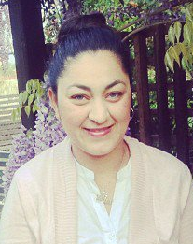

Vedia Akansu was born on 15.03.1985 in Nicosia. She completed Alsancak Primary School in 1996. She graduated from Lapta Yavuzlar Lise in 2002. She studied ‘Architecture’ at Eastern Mediterranean University in 2007.
In 2009 she started her M.A degree studies at Near East University faculty of Architecture. She completed her M.A in November 2011. Her master degree with her thesis ‘A Comperative Analysis of Hous(ing) Developments in Lapta Town and Kayalar Village Kyrenia District’. In 2012 she commenced her Ph.D studies in the ‘Ecological Planing’ and still continuing with Ph.D programme.
She worked as architect at ınfrastructure office, in Nicosia. She began working research asistant in 2010 at Near East University and still continuing as an instructor at Faculty of Architecture.

