FORM
Resim: | 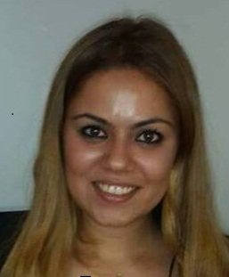
Ünvan: | Uzman
İsim: | ZEYNEP
Soyisim: | GENÇ
E-posta: | zeynep.genc@neu.edu
Bağlı Olduğunuz Bölüm | İŞİTME ENGELLİLER ÖĞRETMENLİĞİ
Biography (tr):1988 yılında Kadirli’de doğdu. Orta öğretimini Özel Biltepe Okulları Kadirli’de gerçekleştirdi. Lise eğitimini Gülten Ali Ziyan Anadolu Lisesi’nde 2007 yılında tamamladı. 2008 yılında Yakın Doğu Üniversitesi Bilgisayar ve Öğretim Teknolojileri Öğretmenliği’ne başladı. 2013 yılında Yakın Doğu Üniversitesi Eğitim Programları ve Öğretimi Ana Bilim Dalı’nda yüksek lisans eğitimine başladı. 2015 yılında yüksek lisans eğitimini tamamladı yine aynı yıl Özel Eğitim Ana Bilim Dalı’nda doktora eğitimine başladı. Eylül 2013 yılından itibaren Yakın Doğu Üniversitesi Eğitim Fakültesinde yarı zamanlı olarak çalışmaktadır.
Biography (en):
Zeynep Genç was born in 1988 in Kadirli. She started her secondary education in Özel Biltepe Okulları and graduated from from secondary high school named Gülten Ali Ziyan Anadolu Lisesi in 2007. She enrolled in Near East University in 2008 and graduated from Department of Computer Education and Educational Technology in 2012. She continued her postgraduate studies at the same university in Graduate School of Educational Sciences Department of Curriculum and Instruction and graduated in 2015. Her PhD studies started in 2015 and still ongoing at Near East University in the Department of Special Education. She is currently working as a part time lecturer in Educational Sciences Faculty.

