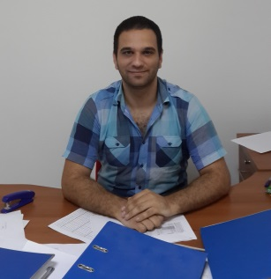
Dr. Vasfi TUĞUN
He was born in Kyrenia in 1988. After completing his primary education in Karaoğlanoğlu Primary School, he completed his secondary education in Anafartalar Lice and Lapta Yavuzlar Lice. He completed his degree in Near East University, Education Faculty in Computer Education and Instructional Technology in 2009. In 2011 after completing his masters degree also in Near East University Computer Education and Instructional Technology Major Field of Study.

After teaching as a part-time between 2009-2011 in Computer Education and Instructional Technology he has been teaching full-time since 2011 until present as a research assistant. He is single and knows English as a foreign language

